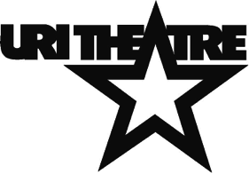 **2015-2016 SEASON**

**In the Next Room (or The Vibrator Play)**

**by Sarah Ruhl**

**October 2015**

**Director: Bryna Wortman**

**Caucasian Chalk Circle**

**by Bertolt Brecht**

**December 2015**

**Director: Vincent Patrone**

**columbinus**

**by the United States Theatre Project**

**written by Stephen Karam and PJ Paparelli**

**dramaturgy by Patricia Hersch**

**conceived by PJ Paparelli**

**February 2016**

**Director: Joe Short**

**Legally Blonde**

**book by Heather Hach**

**Music and Lyrics**

**by Laurence O’Keefe and Nell Benjamin**

**April 2016**

**Director: Paula McGlasson**