Stormwater Conversations: Lessons in Green Infrastructure
RI Green Infrastructure Coalition and Providence Parks Department
September 27, 2018 from 9 AM – 1 PM
Roger Williams Park Casino

AGENDA

9:00 AM Welcome (Meg Kerr, Audubon Society of RI and Brian Byrnes, Providence Parks)

9:15 – 10:00 Municipal projects (2 - 15 min presentations plus Q&A)

  - Green Infrastructure installations at the Newport Gateway and Broadway projects.
Scott Wheeler, City of Newport Department of Public Services, Building & Grounds Supervisor/Tree Warden

  - Green infrastructure for on-site infiltration at Pawtucket Spray Park
Andrew Silvia, City of Pawtucket Department of Public Works, Chief of Project Development
Alicyn Murphy, University of Rhode Island Cooperative Extension

10:00 – 10:45 NGO projects (2 - 15 min presentations plus Q&A)

  - Long term project maintenance: Sara Churgin, Eastern RI Conservation District

  - Leveraging DOT stormwater projects to benefit urban communities: Alicia Lehrer, Woonasquatucket River Watershed Council

10:45 – 10:55– break into groups by colored dots. Two groups are upstairs – two groups are on the main floor.

10:55 – 11:45 – breakout discussions: based on the presentations – and your own experience --

  - What has worked well with these projects? / Suggestions for replicating good practices?

  - What are the challenges? / Suggestions for addressing the challenges?

11:55 – reconvene and report out

12:40 Roger Williams Park Stormwater Research Center – Brian Byrnes
Distribute map of BMPs for self-guided tours after the session

12:55 Wrap up and thanks

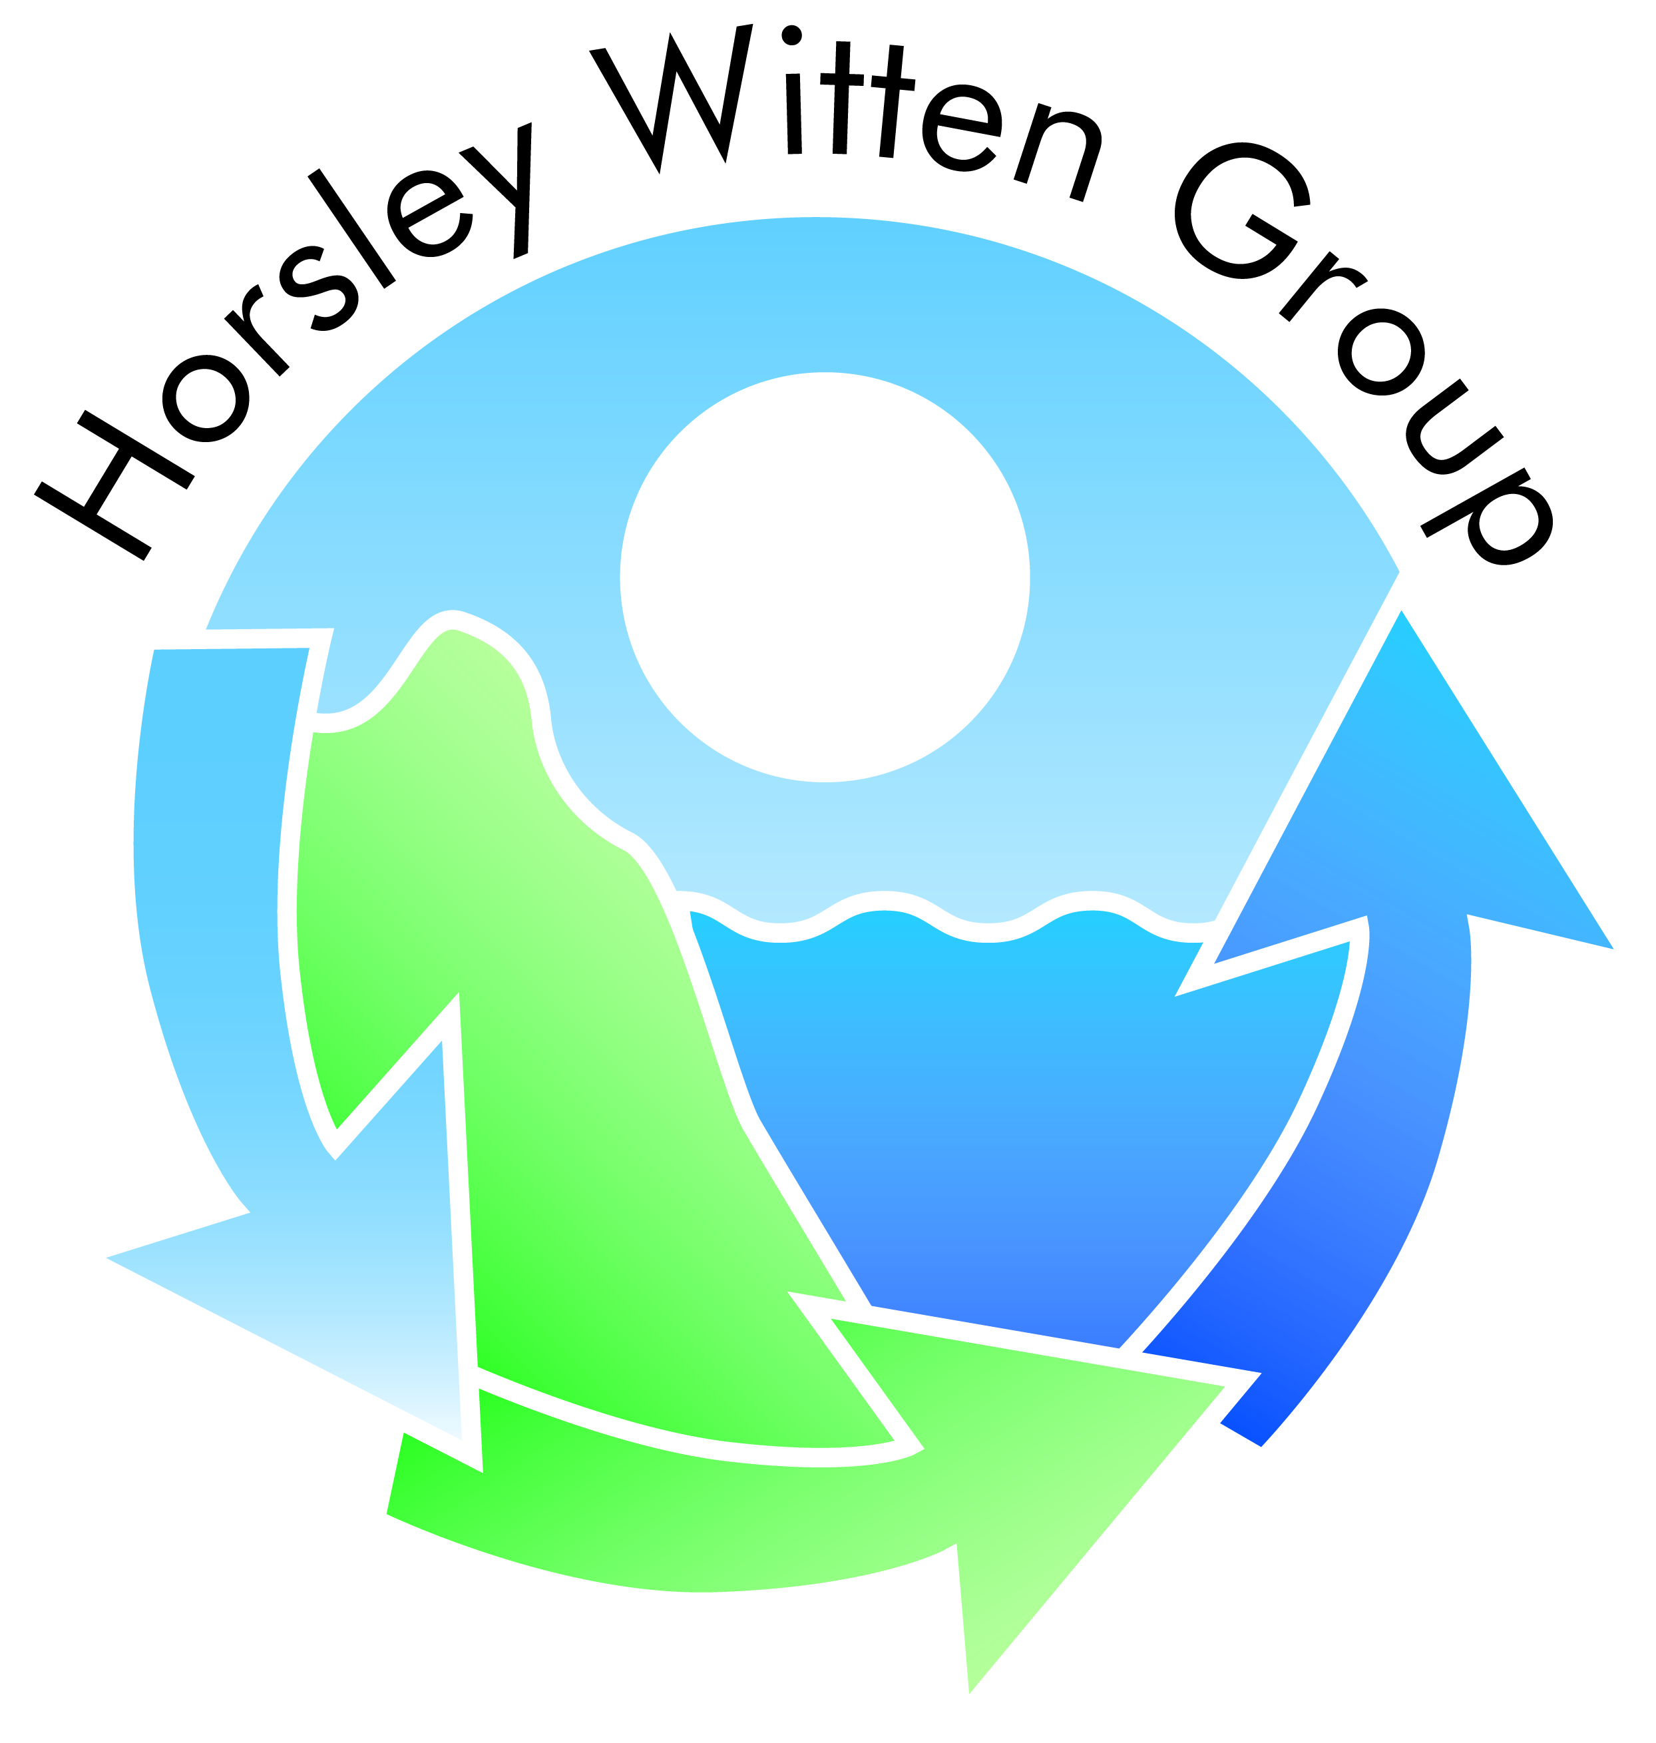
Breakfast provided by Horsley Witten Group

