Community Prescription Savings Programs
Pharmacy | Plan Summary | Fee | Drugs Covered
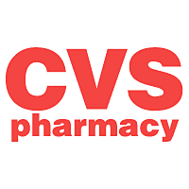 | - $11.99 for 90 day supply  - 10% off MinuteClinic (up to $10/person/visit)  -www.cvs.com/healthsavingspass  -Phone 1-888-616-CARE (2273) | $15/ year | 400+ Generics
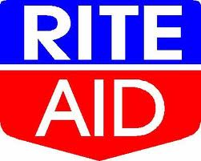 | - 15% off certain prescriptions  - “Flat Fee” Generics  -$9.99/ 30 days  -$15.99/ 90 days  - 15% off select brand names  - Select OCs 28 day - $19.99  - RiteAidTrueTest Strips  50 count - $29.99 | Free | 400+ “Flat Fee” Generics  15% off 1000s of meds
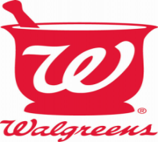 | - 30 day supply : $5, $10 or $15  - 90 day supply: $10, $20 or $30  - 5-20% off immunizations | $20 individual  $35 family | 700+ Generics
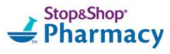 | - $3.99 for 30 day supply  - $9.99 for 90 day supply | Free  (withStop&Shop Card) | 350 Generics
 | Rewards Program-  - $4 for 30 day supply  - $10 for 90 day supply  - 5% shopping pass after filling five eligible prescriptions  Prescription Savings Program-  - Average savings of 10-50% on prescription medications purchased at retail value | Rewards Program:  Free  Prescription Savings Program:  $10/year | 300+ Generics
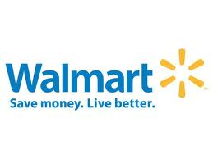 | - $4 for 30 day supply  - $10 for 90 day supply  - free home delivery | Free | 400+ generics
For more details about your pharmacy’s plan, ASK your pharmacist!

Pharmacy Outreach Program
The University of Rhode Island College of Pharmacy
1-800-215-9001
www.uri.edu/pharmacy/outreach

