PeopleSoft Update effective 2/27/18
Effective immediately, there are two important updates to the PeopleSoft system we would like to inform you about:
- Level 4 Approval for Equipment Screening Form (Certification of Unavailability/Unsuitability)
All College Requisitions on fund 500 utilizing category codes:
- 654A (account code 9654) for Capital Equipment
- 660A (account code 9660) for Computer equipment >$5000
Will now route to the Property Department to review that an appropriately signed screening form is attached. The requisition will then be electronically approved and proceed to the Budget Checking process and then come to Purchasing.
The form is available on the Property Department Website: https://web.uri.edu/pss/property-inventory/
For Questions regarding the form or procedures relating to the Property Department; please contact Darlene Pezza, Coordinator for the URI Property Office.

- Fabrication Numbers for Research Projects
All college requisitions utilizing category code 669A (account code 9669) for Components >$5k with Fab #s will now require that the FAB number is entered into PeopleSoft. The FAB number will then print on both the requisition and the purchase order in the area where the chartfield string prints. This will eliminate the need for departments to have to add a comment to the requisition and for the need to ensure that the number is also printed on the PO.
When utilizing category code 669A, you will need to enter the FAB Number in the Distribution Page for each Line Item that is using this category code. The field for this information can be found by navigating from the Main Page to the Schedule Page to the Distribution Page, shown as follows.
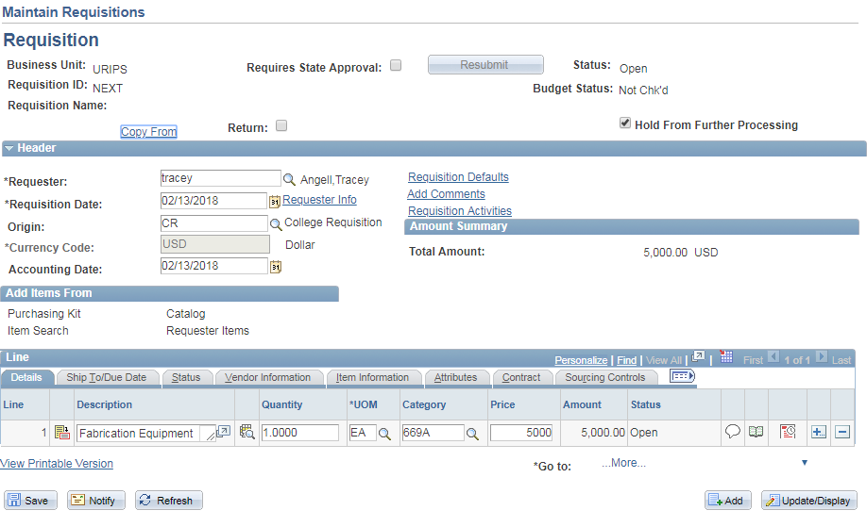
Click HERE to get to the Schedule Page (Shown below)
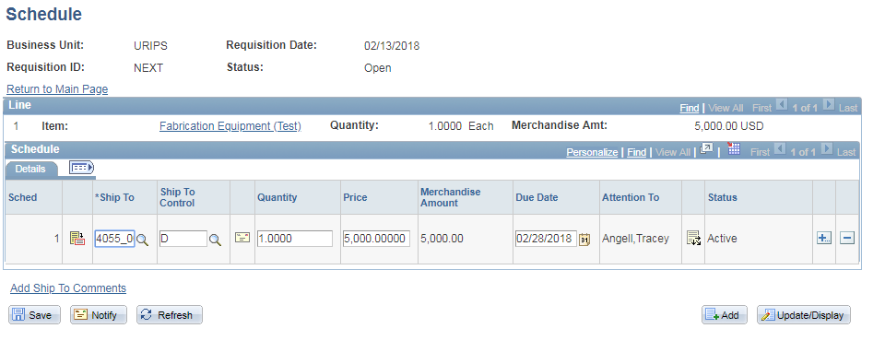
Click HERE to get to the Distribution Page

Once on the Distribution Page, Click on the Tab and enter the FAB Number in the appropriate field.
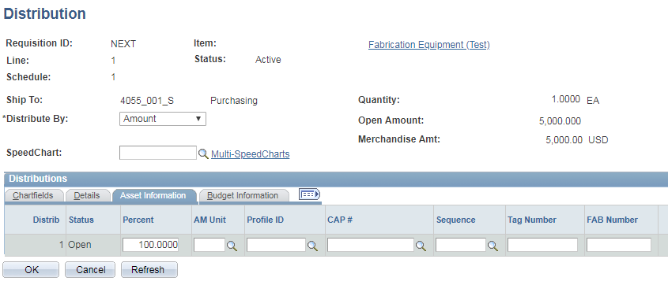
If you have not entered the FAB Number and proceed to Save the requisition, you will get the following message reminding you to do so.
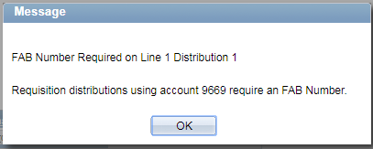

Once saved, the FAB Number will print on the Requisition in the Distribution section of the as shown below.

