TO: Marc B. Parlange, President
Peter Snyder, Vice President, Research and Economic Development
Alyssa Boss, General Counsel
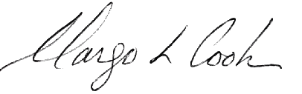
FROM: Margo L. Cook, Board Chair

DATE: November 5, 2021

SUBJECT: Approval of an amendment to the URI Board of Trustees May 8, 2020 Resolution Designating the University of Rhode Island Research Foundation as the Sole and Exclusive Agent of the URI Board of Trustees for Intellectual Property

This correspondence will confirm the action taken by the University of Rhode Island Board of Trustees at its meeting on November 5, 2021 relative to the above-referenced item.

VOTED: That the University of Rhode Island Board of Trustees approve an amendment to the URI Board of Trustees May 8, 2020 Resolution Designating the University of Rhode Island Research Foundation as the Sole and Exclusive Agent of the URI Board of Trustees for Intellectual Property, as set forth in Enclosure 8.c.(ii) and as recommended and presented.

