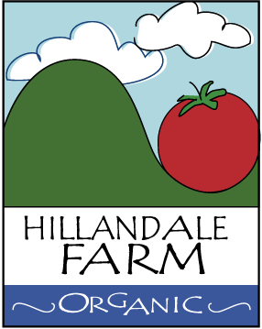

PROPER PRODUCT CONTAINER MAINTENANCE
Containers should be sufficiently maintained so as not to become a source of contamination.
- Product-contact containers (e.g., harvest bins, totes, crates, sacks, buckets, finished product clam shells, bags or packaging films), are stored, or handled (e.g., cleaned prior to post-storage use), so they do not become a source of contamination.
- Food-contact totes, bins, packing materials, other harvest containers, and pallets are visually inspected, clean, intact and free of any foreign materials prior to use.
- The types and construction of product-contact containers and packing materials are suitable to the commodity being handled and suited to their intended purpose.
- Produce is stored in clean and sanitary containers.
- Food-contact totes, bins and other packing containers and equipment designated for packing activities are used for packing activities.
- Food-contact totes, bins and other packing containers and equipment that are no longer cleanable are retired.
- Produce or bins that don’t normally touch the ground during production and transportation are cleaned and/or sanitized to prevent contamination fro rogue pathogens

