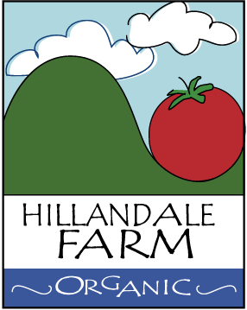

Corrective Action Plan

All employees/operators are aware that when they identify a minor deviation from normal operation, they should:
- Take immediate corrective action
- Communicate the minor deviation and corrective action to their supervisor/partner
All employees have been trained and are aware that when they identify a major deviation from normal operation, they should:
- Immediately report it to their supervisor, partner, or person accountable for food safety onsite?
Supervisors or the person(s) accountable for food safety onsite are aware they must assess the major deviation situation and:
- Determine the required corrective action
- Determine the cause of the major deviation
- Determine the required preventative action needed to prevent recurrence of the major deviation
- Determine new procedures or modifications to current procedures as required to address the identified major deviation, and train employees on the new or modified procedures
- Document the major deviation and corrective actions undertaken?

