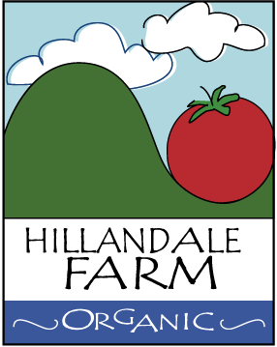

Field to Packinghouse

Hillandale Farm and its employees treat produce just like they treat people – living beings that need to be handled with respect and TLC.

- Produce is not to be thrown into containers or bins.
- Bins or boxes are not to be dropped
- Damaged produce resulting from an accident is to be removed from bins or containers and properly discarded in order to avoid attracting pathogens and further contamination.

