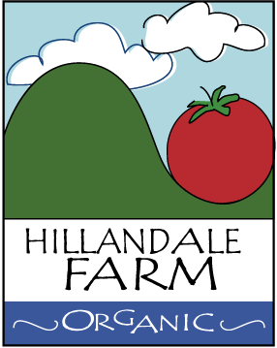

Hillandale Farm Food Safety Policy

Hillandale Farm is an 18 year old certified organic growing operation specializing in tomatoes, select herbs, greens, and seasonal produce. The farm operates at the site of the historic Hillandale Dairy operation and is gradually expanding to include off-site locations like at 23 West Beach Road.

Hillandale Farm caters to high-end restaurants and specialty markets and must adhere to the highest standards in order to meet success; they include:
- Using OMRI-listed inputs for disease and pest management
- Zero tolerance for contamination of fruits and vegetables by chemicals (imported or farm-born)
- All produce being washed and/or cleaned before packaged
- All produce is graded before being packaged
- Harvesting and delivering ripe produce in clean, protective packaging
- Executing daily deliveries or as agreed upon with customer
  - Produce from Hillandale Farm is typically delivered within hours of harvesting by its owners in order to reduce exposure and maximize freshness
- Regular hand washing before and after handling produce and mandatory subsequent to use of bathroom facilities
- As a small farm, its owners know the destination of each pound of produce that is harvested and delivered on a daily basis.

The owners of Hilandale Farm do not grow a commodity but instead meticulously care for and harvest fruits and vegetables for their taste and character to which its customers have grown accustom. There is simply no compromising of this philosophy while always implementing all means possible for protecting food quality, integrity, and safety.

