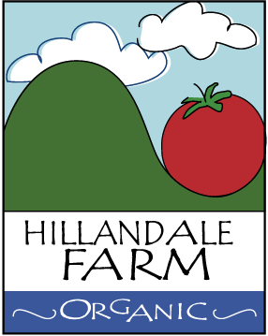

PRODUCE HARVESTING PROCEDURES
- It is a Hillandale Farm policy that only sound produce appropriate for its intended use is harvested, and that produce that has been damaged to an extent that it may be a microbial food safety hazard is not harvested or is culled¹. All relevant employees should be trained in your procedures.
- Produce which shows significant decay, is damaged, has fallen to the ground (unless the product normally grows in contact with the ground) or where there is evidence of contact with animal feces may be contaminated.⁷ It is recommended that this produce not be harvested.
- Any part of the crop contaminated with excrement will not be harvested. Besides not harvesting the specific crop plants found with feces, a radius of 5’ around the contamination will not be harvested¹². If excrement is detected, the crop will be further surveyed to determine if other contamination is present.
- As much dirt, mud and debris as practicable should be removed from the produce before it leaves the field.
- If you wipe produce with cloths, towels, or other cleaning materials during harvesting you need to have a written procedure on how you prevent cross-contamination¹.

