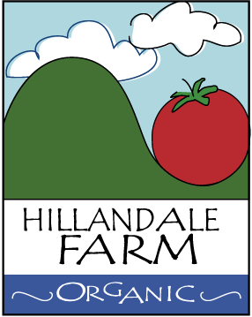

PROTECTIVE CLOTHING POLICY

It is the policy of Hillandale Farm that all of its employees adhere to strict standards in the area of personal hygiene and worker safety for their personal safety and that of the downstream consumer. Below is a list of requirements with which all workers, owners; volunteers; and employees alike, must comply:

- It is recommended that employees wear hair coverings while performing activities in production fields and during produce packing activities. Hats or caps are acceptable hair coverings.
- It is recommended that all farm workers wear gloves. If not, all workers will wash their hands before and after working in fields or greenhouses.
- It is recommended that bracelets, large chains and necklaces not be allowed in the packinghouse or in the field for safety and hygiene reasons³. Items that may be allowed, depending on your requirements, are³:
  - Watches, wedding rings or other fairly simple rings
  - Necklaces that stay covered by clothing
  - Unobtrusive earrings that stay near the head and pose no risk to falling out
  - Other concealed or covered jewelry
- It is recommended that cell phones be kept secure. Cell phones or other items should not be kept in pockets if there is risk of them falling out.

