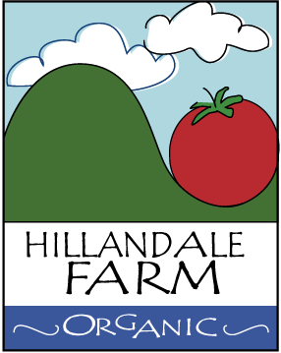

Pest Control Policy

Hillandale Farm maintains a zero tolerance for pests (e.g. rodents) inside production buildings (e.g. greenhouses) or supporting infrastructure (e.g. barns, root cellars, etc.)

When pests are detected, a combination of physical traps and poison are used to exterminate.

All residual poisons are sealed and safely discarded.

Any insects deemed detrimental to buildings or food being stored are dealt with using biological control or eco-friendly methods, consistent with the USDA organic standards.

