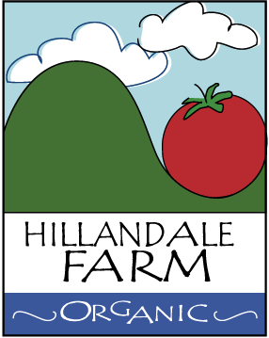

Policy for Controlling Unwanted Debris from Entering Growing Media

It is the policy of Hillandale Farm to exclude unwanted and unnatural debris (e.g. glass, plastic, metal, etc.) from its growing media by:

- Stripping loose or unnecessary parts from any production equipment
- Avoid bringing glass or plastic bottles into the field or greenhouse; instead leave them in a designated break area or someplace where they cannot be intermingled with growing media.
- Remove unnecessary material from pockets
- Secure sheers or knives by using sheaths or cases attached to belts

In general, workers should adhere to the above policy and exercise caution and vigilance when operating in fields or greenhouses in order to prevent contamination. If objects are found, REMOVE them.

