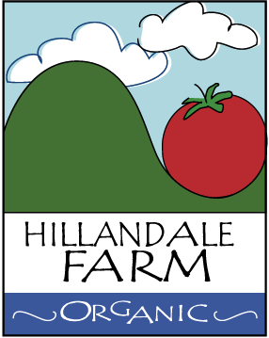

Post-harvest Handling of Produce

- Assigned bins are sanitized at beginning of season and used for specific produce during the course of the harvesting season.
- Produce that isn’t cleaned, packaged, and sent to market daily (within hours of harvesting) is stored in hygienic bins/containers and kept at a relatively consistent temperature and humidity as typical of a root cellar

