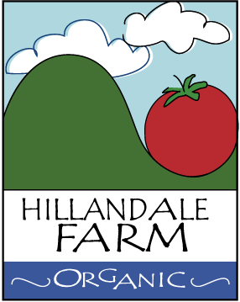

Product Traceability Program

Given the size of Hillandale Farm operations, together with its protocols for quality control, harvesting and deliveries are typically performed by its owners, Mr. and Mrs. Maxson Hence. Occasionally, students participate in harvesting operations, at which time we use a manifest to know which students were involved.

Fruits and vegetables are delivered daily, typically within hours of harvesting, in order to minimize exposure and risk. Every pound is accounted for through logbook and/or invoicing.

