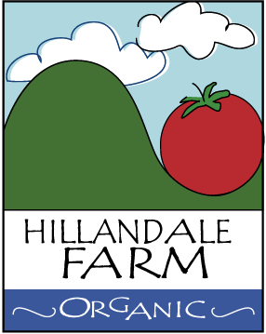

Recall Plan

Below are the protocols in place and to be followed in the event a need to recall food arises:

Contact People:

- Maxson B Hence – 401-255-7192
- Ulrike M Hence – 401-474-1297

1. Record the reason for the recall and the health risk
2. Halt distribution of the product and isolate the quantities still within the operation
3. Identify the product and determine the quantities involved
4. Identify who needs to be contacted
5. Communicate with the parties concerned
6. Recall the product
7. Properly dispose of all contaminated product
8. Determine preventive plans

