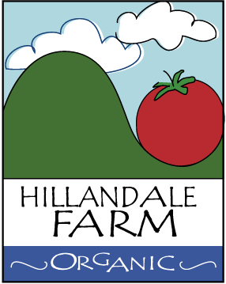

SEWAGE CONTAMINATION TREATMENT PLAN
Hillandale Farm does not operate at sites where there is any risk of sewage spills contaminating produce; however, should there be an exception or an accident that could potentially taint farm produce, the following policy and protocols are in place:
Any sewage spills must be dealt with immediately in a manner that minimizes the risk of contaminating the produce. In the case of a sanitation unit spilling or any other septic leakage occurring in or near field boundaries, the following cleanup steps will be performed:
- Any affected produce is immediately disposed of in a covered waste bin.
- The contaminated area will be marked off with caution tape or string.
- Signs in appropriate languages will be posted at the perimeter prohibiting entry to the contaminated area.
- People and animals will be kept out until the area is sufficiently decontaminated.
- Any solid waste still resting on the surface will be collected, shoveled up, and removed to the waste bin.
- Any affected permanent structures will be hosed off and disinfected with a dilute bleach solution.
- If a sanitation unit has caused the contamination, it will be cleaned up and replaced by the company providing the units and maintenance services.

