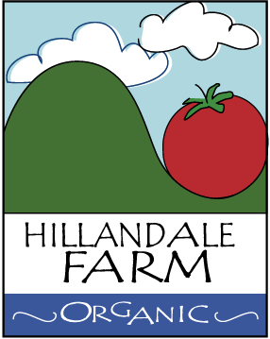

Transportation Hygiene and General Policy

It is the Policy of Hillandale Farm to use fuel-efficient transportation like a small station wagon (or sometimes minivan) to transport produce to market. These vehicles are to be kept reasonably clean on a weekly basis and never carry animals in them. Large clean coolers are to be used for greens during peak summer. Due to the guaranteed freshness of Hillandale Farm produce, fruits and vegetables are almost never in transport for more than 2 hours. Our customers take solace in the fact that their produce arrives still living, and only the most perishable produce (e.g. salad and greens) ever gets refrigerated.

