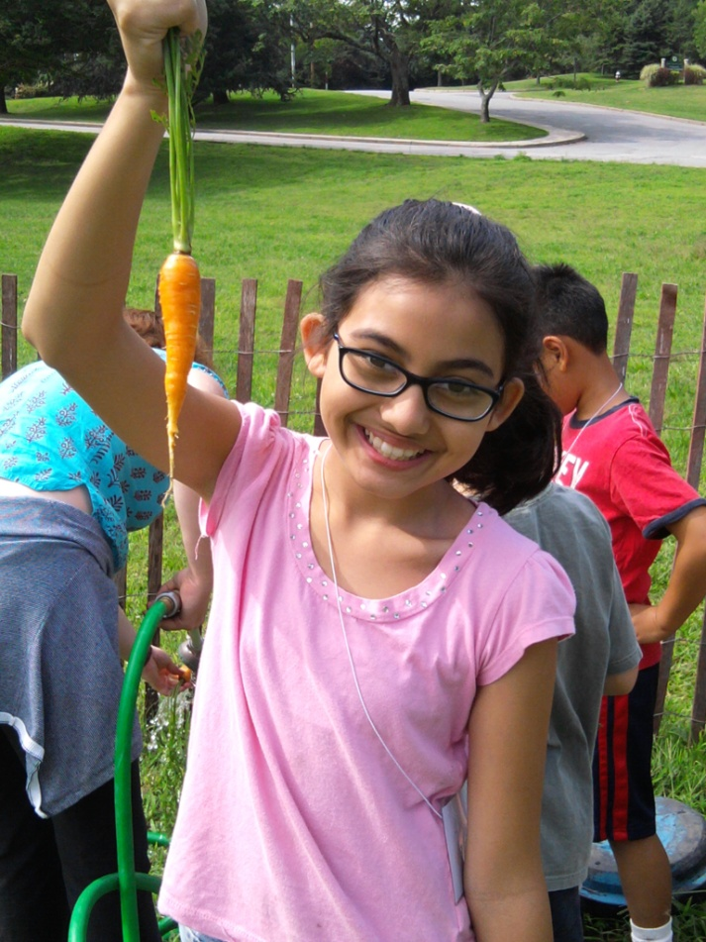
Food
Literacy

Curriculum to inspire the next generation of
food system advocates.

Supporting materials available here: http://www.uri.edu/cels/ceoc/EducationResources.html

Lesson 1a: Benefits of Local Food

This lesson introduces students to the concept of where their food comes from, along with the benefits and drawbacks of buying food locally.
Why is local food good?
1. Transportation and Food Miles
The farther away something comes, the more fossil fuels are burned in the transport of that food.

2. Food Quality and Taste
Local food is consumed right after harvest, so it is fresher and riper. Bananas, in contrast, are picked green and ripen in travel. Many tomatoes are picked green and sprayed with ethylene gas to make them ripen during travel. This results in “red” tomatoes without much taste.

3. Better Farming Practices
Big farms generally grow a few special crops. However, when farmers grow more than one thing, the loss of tomatoes is not as big a deal because they still have potatoes and cucumbers. Also, a smaller scale farm can rotate what is grown in each plot, which keeps the soil healthier by alternating what nutrients are taken out and put back in. Small farms can also put manure on their fields as compost, which reduces the need to put it elsewhere as waste.

4. Support Local Businesses
Local food production protects small farms, local jobs and shops, and increases food security (less dependent on outside sources and can make own decisions about food). In most communities, only 7% of local food dollars stay in the community; and the other 93% pays the processors, packagers, distributors, trucker - all the things that work to increase our food miles.

5. Packaging
Because food processors ship food far from the farm, they use lots of paper and plastic to keep food from spoiling. Think about all the saran wrap and Styrofoam you see at a grocery or corner store. This is difficult or impossible to reuse or recycle. A local farmer can just put his produce in a bin or box and set it out on a table.

What are some criticisms of local food?
- It’s more expensive.
- There’s reduced variety sometimes (ex: you can’t have summer veggies in the winter or varieties from other parts of the world, like bananas)
- Quality control (some apples may have different markings and not look like the shiny, perfect apple)

Resources: http://livinggreen.ifas.ufl.edu/food/local.html,
http://www.nutrition.gov/shopping-cooking-meal-planning/food-shopping-and-meal-planning/farmers-markets

Tips for teaching the lesson: This lesson can be altered to many different teaching styles. If you prefer to use a hand-out or do a vocabulary or spelling lesson using these concepts, this lesson would easily adapt to different objectives.

Materials for the lesson:
“Local Food Visuals” can be downloaded here: http://www.uri.edu/cels/ceoc/EducationResources.html

Name: Where does our food come from? |  | Topic: Food Literacy
Subject: Language Arts, Geography |  | Grade Level: 4-12
Objective(s): Student will be able to (SWBAT) describe where the food they eat comes from, as well as identify the processes behind receiving the food that they eat.
State Standard(s): CCSS.ELA-Literacy.SL.4.1d. Review the key ideas expressed and explain their own ideas and understanding in light of the discussion.
G 3 (3-4) -2a Students understand the interrelationships of geography with resources by comparing products produced locally and far away (e.g. apples from Scituate vs. oranges from Florida)
G 4 (7-8)-1a Students explain how humans depend on their environment by analyzing how human dependence on the environment impacts political, economic and social decisions.
Time | Action |  | Assessment | Materials
5-10 mins | Hold up each local food visual as you proceed through the discussion. Introduction: Discuss the transport of food. How far do you think the average grocery store’s produce travels between where it is grown and your fridge? Nearly 1,500 miles. 40% of our fruit is produced overseas. |  | How far is food transported?  How far do you think an average grocery store’s produce travels between when it is grown and when it gets to your fridge? | Local Food Visuals
3-5 min | Discuss better farming practices. Small farmers can use practices like adding compost, planting a larger diversity of species and crop rotation. |  | Do large farms plant a diversity of food crops? What would happen if an insect or disease wiped out one crop? What do farmers do to add nutrients back into the soil?

Time | Action | Assessment | Materials
3-5 mins | Discuss food quality and taste. Many foods lose nutrients and quality in the transport process. | What are some of your favorite fruits and vegetables?  What kinds of fruits are grown overseas?
3-5 mins | Discuss how local food supports local businesses. | What does a farmer do? How does he make money? What other jobs are focused around food?
3-5 mins | Discuss food packaging. Think about all the saran wrap and Styrofoam used in grocery stores. This is difficult or impossible to reuse or recycle. | What are some of the pros and cons of the packaging of our favorite foods?  How do local farmers package their produce?
3-5 mins | Discuss the drawbacks to eating locally. This relates to the price, diversity of food available and quality control. | Is food bought at the farmers’ market more or less expensive than the grocery store? Does an apple at the farmers’ market look different?

Lesson Plan 1b: Food Miles Demonstration

The objective of this activity is for students to visualize the distances our food travels to reach us. They will be able to place a number of miles with foods that are imported to the U.S from other countries.

Materials used in this lesson: Food mile line, various fruits, vegetables, milk carton, egg carton, cheese wrapper, etc.

How to construct your food mile line:

Materials needed: Yarn, paper, scissors, markers, hole punch

- Measure out a piece of yarn as long as your classroom will allow.

- Cut out squares that will be “mile markers” for your line. Labeling these squares will depend upon which food items you plan to bring in for the game (i.e. Rhody Fresh Milk might be around 15 miles, while an orange from Florida would be about 1,300 miles).

- Once all of your “mile markers” are labeled, hole punch and slide onto your string. Arrange the markers in a way that is more or less to scale, so you have a good representation of how far away each item is really coming from.

- Tie a knot around each hole so that your markers are secure, and you are ready to play!

Objective(s): SWBAT identify and locate where certain foods come from and visualize a numeric value of how far their food must travel before reaching our table.
State Standard(s):
C&G 5(3-4) -2. Students demonstrate an understanding of the benefits and challenges of an interconnected world by exploring current issues using a variety of print and non-print sources (e.g. Where does food come from?).
G 1 (7-8) –1 Students understand maps, globes, and other geographic tools and technologies by analyzing charts and graphs to interpret geographical information.
G 1 (9-12) –1 Students understand maps, globes, and other geographic tools and technologies by analyzing how place shapes events and how places may be changed by events (e.g. historical, scientific) and making the connection between location and decisions about land use.
Time | Action | Assessment | Materials
5-7 mins | Introduction: Explain the exercise to the class. We will be looking at various foods and deciding where they come from in the world and how many miles they travel from farm to plate. | What are some foods that are grown locally? What kinds of farms have you seen around the state? What are some foods that are grown overseas? (Can list on board) | Black/White board, chalk, markers
10-15 mins | Introduce the food items. Students then place each item along the string next to the appropriate number of miles they believe it traveled. Reveal the place of origin and food miles traveled at the end. (i.e., This carton of milk was produced in RI, but this pineapple traveled 5,000 miles from Hawaii to RI). | What is this? Who likes to eat this? Where do you think this was grown? How many miles away do you think this is? | Food items: milk carton, pineapple, cheese wrapper, etc. Alternatively you could use printouts to represent each item.

Lesson Plan 2a: Food Deserts

This lesson introduces students to the concepts of Food Deserts. Food deserts are defined by the US Dept. of Agriculture as areas without access to fresh, healthy, affordable food. This will give students a chance to investigate food justice issues, by voicing their opinions on various topics based on food access.

Tips for teaching: See the Food Access Resource Atlas to find out where food deserts occur locally: http://www.ers.usda.gov/data-products/food-access-research-atlas.aspx#.UWamRLWmiAg
Agree/Disagree cards can be downloaded from: http://www.uri.edu/cels/ceoc/EducationResources.html

Name: Food Deserts | Topic: Food Literacy
Subject: Social Studies, Geography | Grade Level: 4-12
Objective(s): SWBAT identify a food desert and areas in the community where healthy and affordable food options are scarce.
State Standard(s):
G 3 (3-4) -3a Students understand how geography influences human settlement, cooperation or conflict by describing how features of a place influence human decision making (activities, settlement employment).

E1 (5-6)-2a Students demonstrate an understanding that scarcity and abundance causes individuals to make economic choices by comparing the cost and benefits of consumer and producer choices to determine value.

E1 (5-6) -3a OR b Students demonstrate an understanding that societies develop different ways to deal with scarcity and abundance by (A) describing the distribution of goods and services OR (B) identifying how scarcity impacts the movement of people and goods.

Time | Action | Assessment | Materials
3-5 mins | Place signs around in separate corners |  | Prepared labeled agree, disagree signs (see page 10-13)
10-15 mins | Instruct students to walk to the sign that best represents their feelings about the statements you will read, and then talk with their peers who chose the same sign to discuss their stance. Allow 3-5 mins. for discussion per topic. | Statements: It is easy to eat healthy food. Limited access to a supermarket can be linked to obesity. Supermarket chains should be forced to build in urban and rural areas, not just suburban areas. (This final statement may require defining urban, suburban and rural areas).
10-15 mins | After each discussion, have students present their stance as a group. After each group has spoken, if students feel they agree with another group more than their original choice, they may change corners but must defend their decision for switching.  Repeat this process for each statement read to the class. | Why did you change your mind?

Lesson Plan 2b Food Desert Group Brainstorm

Objective(s): SWBAT identify the meaning of a “food desert”, work in groups to discuss and answer a series of questions regarding these food deserts.
State Standard(s):
CCSS.ELA-Literacy.W.4.1 Write opinion pieces on topics or texts, supporting a point of view with reasons and information.
Time | Action | Assessment | Materials
3-5 mins | Write the term “food desert” on the board. As a class, discuss what the term means. A food desert is an area (community, neighborhood, etc.) where healthy, affordable food is difficult to obtain. |  | White/black board
10 mins | Have kids split into pairs or groups to work on answering three of the following questions. Question sheets can be prepared ahead of time. | Why might healthy affordable food be difficult to obtain in certain areas? Where would you think food deserts are most prevalent: urban, suburban or rural areas? How do you think living in a food desert could affect a person or families’ food choice? Other than grocery stores, where else can food be purchased? How might food options in convenience stores or fast food establishments be less healthy and/or more expensive? How could living in a food desert relate to food insecurity (hunger)? Obesity?

Lesson Plan 3: Personalized Food Mapping

This exercise is designed to give students a visual understanding of where they eat their food on a day-to-day basis. Students will create a personalized food map that is unique to each creator. The objective is not in making maps with accurate distances and drawn to scale, but rather correctly identifying the locations where they eat through the use of landmarks. Students will take mapping concepts, introduced through the food desert discussion, and learn different ways to get their food, and what affects those decisions.

Materials for the lesson: Paper, crayons, colored pencils, markers, magazines, scissors, and glue sticks

Tips for teaching: This activity leaves a lot of room for creativity. You could make the maps from a collage of pictures students could get from old magazines and newspapers instead of drawing pictures for example. You could announce the upcoming project a day in advance and instruct each student to bring in an old magazine to cut pictures out of as a homework assignment.

Name: Personalized Food Mapping | Topic: Food Literacy
Subject: Geography | Grade Level: 4-12
Objective(s): SWBAT create through visualization the locations where food is consumed through their day to day life. Students will make connections between their physical environment and their daily activities.
State Standard(s):
G 1 (3-4) -2a Students identify the characteristics and features of maps by applying map skills to represent a location (e.g., design a map)
G 1 (5-12) –1 Students understand maps, globes, and other geographic tools and technologies…

Time | Action | Assessment | Materials
5-7 mins | Discuss the idea behind this exercise. A landmark is a point or place that is important in identifying a location and is usually highlighted on a map. For this exercise, landmarks will be the locations where students eat their food (this can be a house, school, restaurant, garden, etc). Display example. | What is a landmark? | Model food map, can be drawn as a picture on the board. White board/chalkboard, markers or chalk.
3-5 mins | Instruct students to draw the path they take each day to get their food, with landmarks along the way with their favorite meal to eat at each landmark. Between each landmark, draw or collage your way of getting there. (Bicycle, walking, car, etc.) | Do you walk home from school? Do you ride your bike to a restaurant? Do you drive through a restaurant? | Paper, colored pencils, crayons, markers, magazines, scissors, etc.
15 mins | Have students draw their ideal food map.
15 mins | Discuss students’ completed maps. Have students explain their map to the class. | What are the important landmarks depicted in your map? What do you wish you could add?

Lesson Plan 4: The Food Miles Game
(Indoor or Outdoor)

This lesson provides a comprehensive look at the origin of the food we eat at the dinner table. Students will cooperate as a group to investigate the food system and decide how each component of a meal reaches us.

Students will use critical thinking skills to put the processes leading to the creation of their spaghetti dinner in the correct order. For example, Swiss cheese starts from milk (cows), is processed (cheese factory), shipped (plane then truck), and finally reaches the grocer. The transportation methods must be logical (i.e., cheese from Switzerland must cross the Atlantic Ocean and thus cannot reach us by truck only).

Tips on teaching: Lay out the food system sheets in no particular order, and prepare order cards for each group ahead of time. This activity works in the classroom or outside.

Game pieces can be downloaded from: http://www.uri.edu/cels/ceoc/EducationResources.html

Name: The Food Miles Game | Topic: Food Literacy
Subject: Social studies | Grade Level: 4-12
Objective(s): SWBAT work as a group to understand how their food reaches the dinner table by breaking down where each component of a meal.
State Standard(s):
G 3 (3-4) -2a Students understand the interrelationships of geography with resources by comparing products produced locally and far away (e.g. apples from Scituate vs. oranges from Florida).
HP 2 (5-6)-1a. Students connect the past with the present by identifying sequential events, people, and societies that have shaped RI today.

Time | Action | Assessment | Materials
3-5 mins | Prepare your game area by placing the food system sheets around your classroom or garden (Airplane, supermarket, etc.). |  | Food system sheets (see below)
3 mins | Divide students into equal teams of the same size.
3 mins | Provide each team with three stacks of order cards; each stack will be marked cheese, wheat or tomatoes numbered 1-6. |  | Order cards (see below)
10-15 mins | Each group must work together to identify how each product makes it to their local store. Direct students to place their order cards on each food system sheet in the correct order. Discuss the students’ choices. | Do you have all of the pieces? Do you understand your task? Which order did your group decide upon? Explain your reasoning.
10 min | Once students have completed this exercise, walk as a group through the process to make cheese, pasta and sauce, and discuss the conventional versus local food systems. | What is a logical shipping method for cheese sourced from Switzerland vs. Wisconsin? Will a tomato from California be as fresh and nutritious as a local tomato purchased at the farmers’ market? Besides the quality of the food, what other environmental consequences result from the food transport process?

Acknowledgements

Grateful acknowledgement of the following for their insight, expertise, and support in creating this curriculum:
Lillian Matthews
Brittany Dobrzynski
Stephannie Kimura
Christian (CJ) Sanchez
Vanessa Venturini

of the URI Outreach Center.

