Gallery walk for introduction to unit on estuaries.

Purpose : To introduce students to concepts that will be covered in this unit on estuaries. To stimulate thinking and conversation.

On chart paper have the following images with questions.

Have students walk around room, and using post its , answer questions and put onto chart paper.

When students are complete, walk around with students and review answers posted onto paper.

Station 1:

Display different pictures of estuaries.

Question: These are all pictures of estuaries. What features do they have in common?

Station 2:

Show pictures of trash vortexes.

Question: These are found in all of the major oceans of the world. What do you think they are?

What impact do you think they have on ocean life?

Station 3:

Show the following food web

http://estuaries.noaa.gov/Teachers/pdf/food-pyramid/LEfoodweb.pdf

Question: What would happen to the organisms in this estuary ecosystem if the population of mayfly nymphs was depleted due to pollution?

Station 4: Use the image from the following site....

http://oceanservice.noaa.gov/education/tutorial_estuaries/media/supp_est10b_depth.html

Include the caption.

Question: Explain how you think humans have impacted water levels in estuaries.

Station 5: Show a picture of a cargo ships.

Question: Why do you think estuaries are important for cargo ships?

Station 6: Show the following cartoon
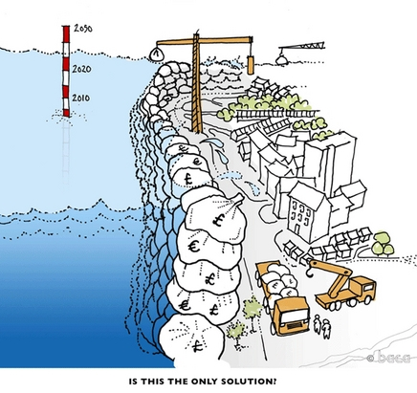
Question: What is the message that this cartoonist is trying to convey?

