INTRO TO ESTUARIES

- How are estuaries connected to watersheds?
  - Show with a Video - http://www.earthlive.org/tv/index_tv.htm (Drop by drop to the sea) OR http://estuaries.noaa.gov/Estuarylive/VideoGallery.aspx
  - Show with Google Maps / Earth – locate your school and pan out to see how the local river is connected to Narragansett Bay and the Atlantic Ocean
  - Background info about Narragansett Bay = an estuary (one of 28 National Estuarine Research Reserves in the US, which are protected areas that include coastal lands and waters overseen by NOAA)
    - The mission of the National Estuarine Research Reserve System (NERRS) is to link stewardship, education, and research in order to better understand and manage estuarine resources. Estuaries include environments that have traditionally been viewed as “waste lands” by many segments of society. Salt marshes and tidal flats have been drained and filled on a wide scale. Only fairly recently has the public become aware of the vital ecological roles that these coastal habitats play. The research and educational activities at the local level of the estuarine reserves have helped to increase public knowledge and awareness of the value of these resources.
- What is an estuary – they are where rivers meet the sea. Estuaries are especially important edges – places where the land meets the sea, mixing fresh and salt water. Estuaries are critical transition zones between uplands, their watersheds and the open ocean, providing habitat linkages for a diverse array of plants, fishes, birds and mammals
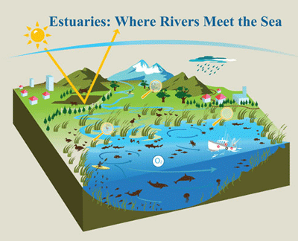
  - ALL: Good website for multiple estuary resources - http://omp.gso.uri.edu/ompweb/doee/teacher/internt1.htm
  - ELEM. & MS: Good for elementary and middle, includes online interactive GAMES- http://water.epa.gov/learn/kids/estuaries/index.cfm

