OUR POLLUTED SEAS
As you have seen on Google Earth when you traced the flow of water from your school site to nearby water bodies, streams and rivers, ultimately what ends up in our water supply finds its way into Narragansett Bay and from there to the Atlantic Ocean. This is a natural part of the water cycle.
However, it is estimated that 80% of the marine debris in the world’s oceans originates from land-based sources, primarily from the trash and debris in stormwater and urban run-off. The negative impact that our actions and choices are having on this vital natural process should be of major concern to everyone. Our oceans have become floating garbage dumps!
In 1994, Captain Charles Moore founded Algalita Marine Research Institute to focus primarily on the “coastal ocean" in California, specifically on the restoration of kelp forests and the improvement of water quality through the preservation and re-construction of damaged wetlands along the California coast. In 1997, this focus dramatically changed. While sailing from Hawaii to California aboard his 50-foot catamaran, the Alguita, he charted a course through the North Pacific Subtropical Gyre. This area of the Pacific (one of the five ocean systems worldwide) is a circulating rotation of ocean currents and is normally avoided by sailors due to its light winds. What he saw there was an ocean that he had never known: "Every time I came on deck to survey the horizon, I saw a soap bottle, bottle cap or a shard of plastic waste bobbing by. Here I was in the middle of the ocean and there was nowhere I could go to avoid the plastic."
The North Pacific Gyre, now commonly referred to as the Great Pacific Garbage Patch, is a vast PLASTIC SOUP of pollution from the surface down through the water column, containing everything from large abandoned fishing nets (ghost nets) to plastic bottles, bottle caps, toothbrushes, containers, boxes, to miniscule particles of plastic that have either been reduced from larger pieces by wave action or sunlight (photo-degradation). Captain Moore has estimated that the number of pieces of plastic trapped in the Gyre outnumber marine life by a ratio of 6:1.
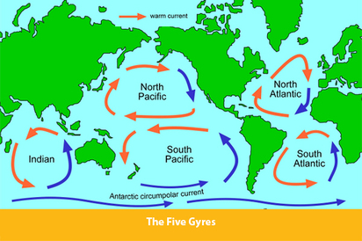
SEE: www.algalita.org
Although plastics in the ocean will photo-degrade with exposure to light over time, it only breaks down into ever smaller pieces. These tiny particles WILL NOT breakdown biologically and disappear, and are suspended floating in the water FOREVER, threatening all components of the marine ecosystem.
These small pieces of plastic are often eaten by marine animals who mistake them for food. There is no nutritional value for them in plastic, and the animals can literally starve to death from eating this plastic ‘food’. Another huge concern is that these plastic pieces attract persistent organic pollutants also present in sea water, which readily bind to their surfaces. These POP particles are then concentrated in the organism’s stomach and tissues, and their impact is further magnified as they pass up the food chain. Research is currently underway worldwide to try and determine exactly what the effects of this unnatural diet will be on the top consumers in the food chain—man included.
SEE: Plastic Sushi Anyone? http://vimeo.com/8306883
Larger pieces of plastic like abandoned nets, ropes, fishing lines, containers etc. pose dangers to marine animals as they can become entangled, trapped and suffocated in them. The only slight advantage to this type of pollution is that it is highly visible and in theory can be removed from the environment, if there is a concerted effort to do so. This is why beach clean-ups are an important stewardship project that everyone should participate in. Removing this waste to a landfill site (which in turn has environmental consequences) at the very least keeps it from contributing to the plastic soup phenomenon.
Removing miniscule plastic pieces from the open ocean poses a much more significant problem and one that is not readily easy to solve. Unconfirmed reports from the United Nations Environment Program (UNEP 2005, 2006) estimated 13000-18000 pieces of plastic floating in every square kilometer in the oceans, from the Arctic to Antarctica. The plastic is not just on the surface, but suspended in the water column to a depth of 90’. There is no practical or economically viable way to sift out this debris without also removing/harming significant numbers of marine organisms.

SO WHAT CAN BE DONE?
Educating consumers is the best long term solution to this global problem. We as a species need to drastically reduce our addiction to plastics, and the mission starts with you! The world needs you to start addressing these global issues locally by reducing plastics use at home, school, work, and in your wider community.
One of the most obvious symbols of our throw-away culture is the plastic bag (plastic water bottles are also a close contender). According to statistics compiled by Earth 911, 100 billion bags are used in the US each year, with 1 trillion used worldwide, which equates to 1 million bags used every minute! It is estimated that the average family acquires/consumes 15 bags after each trip to the grocery store, and will use 500 plastic bottles annually.
CoastalCare.org estimates that the production of plastic bags creates enough solid waste per year to fill the Empire State Building 2.5 times. The petroleum used to make only 14 plastic bags could drive a car 1 mile. In the US, attempts to ban/curtail/or make consumers pay for the use of plastic bags have met with strong resistance. The plastics industry has a powerful lobby in Washington that argues that jobs will disappear if plastic bags are banned. It estimates the industry employs some two million workers. However, Americans alone throw out at least 100 billion bags a year, the equivalent of throwing away 12 million gallons of oil—a totally unacceptable waste of money and resources. Until Congress passes nationwide laws targeting the reduction of plastic bags, individuals must make a conscious choice to refuse to use them (or use the ones we already have).
Surfrider.org has the program “Rise Above Plastics” which encourages active participation from its members, and has an Activist Toolkit (under Resources tab) with suggestions and ideas on how to spread the word, including:

Ten Easy Ways to Rise above Plastics and reduce your “plastic footprint’:
- Choose to reuse when it comes to shopping bags and bottled water. Cloth bags and metal or glass reusable bottles are available locally at great prices.
- Refuse single-serving packaging, excess packaging, straws and other 'disposable' plastics. Carry reusable utensils in your purse, backpack or car to use at BBQ's, potlucks or take-out restaurants.
- Reduce everyday plastics such as sandwich bags and juice cartons by replacing them with a reusable lunch bag/box that includes a thermos.
- Bring your to-go mug with you to the coffee shop, smoothie shop or restaurants that let you use them. A great way to reduce lids, plastic cups and/or plastic-lined cups.
- Go digital! No need for plastic CDs, DVDs and jewel cases when you can buy your music and videos online. Seek out alternatives to the plastic items that you rely on.
- Recycle. If you must use plastic, try to choose #1 (PETE) or #2 (HDPE), which are the most commonly recycled plastics. Avoid plastic bags and polystyrene foam as both typically have very low recycling rates.
- Volunteer at a beach cleanup. Surfrider Foundation Chapters often hold cleanups monthly or more frequently.
- Support plastic bag bans, polystyrene foam bans and bottle recycling bills.
- Spread the word. Talk to your family and friends about why it is important to Rise Above Plastics!
OTHER ACTIVITIES (STEWARDSHIP?):
- Create make the change/thank you cards to give out to local businesses.
See examples below from www.plasticfreeseas.org for ideas on what to say, or just use your own words, on why everyone should reduce their “plastic footprint”.
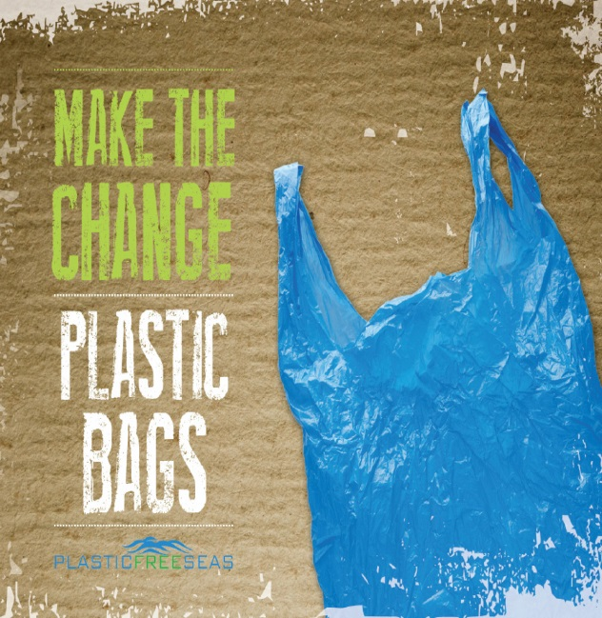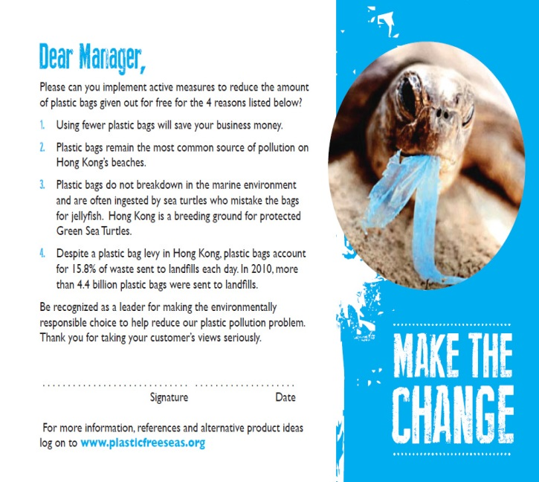

- Take part in the International Coastal Clean-up Day, September 20, 2014 collect trash and data for worldwide distribution for ongoing research on what trash is ending up in our oceans.
- Stop using disposable/one-use plastic items at home.
- Organize a campaign in your school to minimize the use of disposable plastic items like bottles, forks, cups, plates and other containers. Speak to the food service provider at your school to research the cost and benefits of using bio-degradable plastic serving containers etc. instead of disposable ones.
- Investigate the costs of changing from disposable plastic cups/plates to reusable plates (probably still plastic, but glass/china may be available).
- Present findings to school committee and educate them on the problems with plastics and why your school should make the change.
- Encourage classmates to bring their own water bottles not one use plastic ones
- Re-purpose a glass SNAPPLE bottle or similar as a personal water bottle, rather than using a plastic one. Get creative and design a holder or pouch to protect the bottle, and a strap to carry it.
- See: http://www.youtube.com/watch?v=Ay1yp-GaRws for ideas on how to use duct tape to create a water bottle carrier.
- Recycle plastic bags to ‘crochet’ a carrying pouch, or heavy duty REUSABLE
Water bottle holder/shopping bag etc.

RESOURCES:
A few of the amazing organizations that are on the cutting edge of research into pollution in our seas, which offer opportunities and suggestions for how you can get involved.
www.plasticsoupfoundation.org (Dutch website, click on English version)
www.5gyres.org
www.algalita.org
www.plasticfreeseas.org (Hong Kong based non-profit)
www.surfrider.org (international orgaanisation with RI chapter)
www.coastalcare.org
OUR POLLUTED SEAS: THE TROUBLE WITH MICROBEADS
Microbeads were originally created in 1976 by Dr. John Ugelstad of the University of Trondheim, Norway. Dr. Ugelstad developed a method to create uniformly sized spherical microbeads of polystyrene, which have many uses in biotechnology and in biomedical research. Because of their uniformity of size, shape and surface area, microbeads provide optimal sites for rapid and efficient chemical binding. Microbeads, and magnetic separation technology, have enabled a range of innovative methods to benefit research on disease prevention, medicine, and other scientific fields and have helped improve the human condition.
Unfortunately however, the problem with microbeads stems from their more recent widespread use in personal care products such as toothpaste, shaving cream, shower gel and exfoliating scrubs, which contain thousands of these minuscule balls of plastic. Over the years, these tiny plastic balls have replaced more traditional, biodegradable exfoliating or abrasive ingredients such as ground nut shells, sugar or salt crystals. These tiny pieces of plastic are washed down the drain after use, and are so small that they are not filtered out by waste treatment plants. Ultimately they end up in our water bodies, streams, rivers and oceans where they do not biodegrade or break down. Instead, they contribute to the “plastic soup” which is threatening our planet’s oceans.

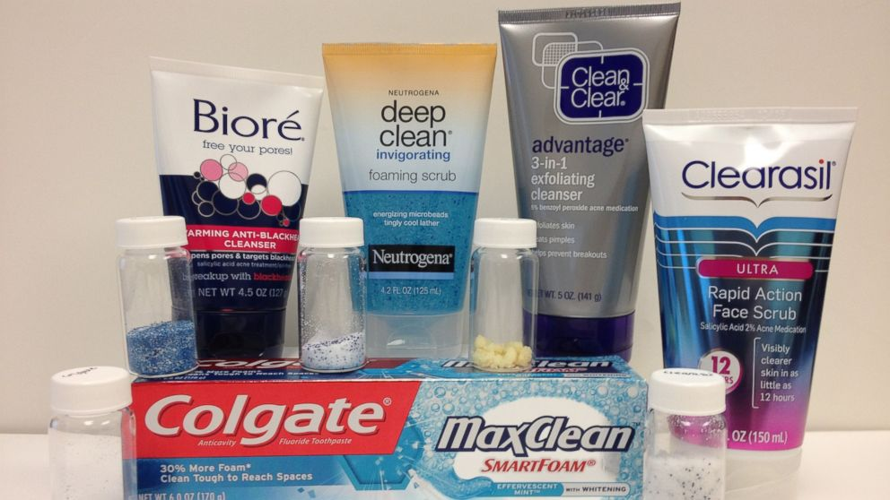
A selection of products that contain microbeads of plastic

Microplastics are generally defined as plastic pieces or fibers measuring less than 5 mm. The microbeads found in personal care products are almost always smaller than 1 mm. and can make up as much as 10% of the volume of a product. Not only do these bits of plastic not biodegrade, but they are also similar in size to the plankton and other organisms that many marine animals feed upon, meaning that microplastics are now found in animals throughout the marine food chain.
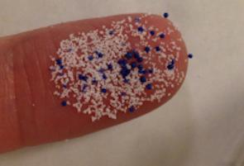
Because of their size, microbeads pass through the filtration systems at waste water treatment facilities and back into the water cycle. These plastic particles are a concern in other bodies of water also-three of the five Great Lakes—Superior, Huron and Erie—have a high concentration of plastic microbeads. According to an article in the Scientific American, chemists Sherri Mason of SUNY-Fredonia and Lorena Rios of UWisconsin-Superior found 1,500 to 1.7 million plastic particles per square mile in the lakes, with the highest concentrations found in Lake Erie.
According to Dr. Rios, microbeads are essentially “solid oil” balls that absorb other chemicals in the water like a sponge. She reports that the level of certain Persistant Organic Pollutants is much higher in the Great Lakes than the Atlantic Ocean, but only because the ocean’s greater size dilutes the toxicity of the plastic particles. The pollutants remain in the environment for more than 50 years and can accumulate in fish and other organisms, proceeding up the food chain on ingestion by other species. Some of the compounds identified in the study are classified as endocrine disrupters, meaning they affect hormone levels and systems in plants, animals and even people. "We don't know what's going on yet with the fish or the organisms eating the plastic with these pollutants in the Great Lakes," Rios says. "I plan to study whether the endocrine system of the fish is damaged and whether the problem stops there or moves up the food chain in harmful amounts all the way to humans."
In 2011, a Dutch non-profit group, the North Sea Foundation, in response to growing alarm about the amount, and consequences of, plastic in the world’s oceans started writing to companies to ask them to stop using microbeads in their products as soon as possible. Unfortunately, many of the manufacturers refused, instead claiming that they were safe to use and posed no harm to the environment.
None of the manufacturers had scientific data to support their claims. In the summer of 2012, The Plastic Soup Foundation partnered with the North Sea Foundation and launched the BeatThe Microbead campaign, which asks:
- Manufacturers to stop using microbeads;
- Retailers not to sell products containing microbeads;
- Consumers to refrain from buying products containing microbeads;
- Governments to ban the use of microbeads in personal care products as soon as possible.
They also created a smartphone application that allows consumers to follow their campaign and participate by identifying products that contain microplastics. This data is compiled and adds to the pressure that can be put on manufacturers to change their products.
In the US, Illinois became the first U.S. state to enact legislation banning the manufacture and sale of products containing microbeads; the ban goes into effect in stages in 2018 and 2019. In May 2014, The New York State Assembly voted to ban the use of microbeads in personal health care products, and Ohio and California are also considering legislation. The Personal Care Products Council, a lobbyist/trade group for the cosmetic industry, supports the Illinois bill, which bans the sale of personal care products with microbeads by 2019. As a result of the campaign several major beauty companies such as The Body Shop, Johnson & Johnson, L’Oréal and Procter & Gamble have pledged to phase out plastic microbeads from their products. However, some of these companies have not specified a time period for eliminating them, and still need to be reminded by consumers to BAN THE BEAD!

SO WHAT CAN BE DONE?
The microbeads used in personal care products are mainly made of polyethylene (PE), but can be also be made of polypropylene (PP), polyethylene terephthalate (PET), polymethyl methacrylate (PMMA) and nylon. They are generally used as abrasives, to scrub skin, teeth or your scalp, and must be included on a product’s list of ingredients. They may be visible in the product as little colored balls.
- READ THE LABEL!
- Bring in items from home that you use, such as; toothpaste, shampoo, soap, facial scrubs or acne products. Some household cleaners for scrubbing sinks or dishes may also contain microbeads. Read the labels on different
- Check the list of ingredients to see if it contains any of these plastics: polyethylene (PE), polypropylene (PP), polyethylene terephthalate (PET), polymethyl methacrylate (PMMA) and nylon. Unfortunately, the manufacturers are only required to put the full list of ingredients on the outer packaging, so an actual tube of toothpaste may only show the ‘ active’ ingredients. Check all packaging for ingredients list. NOTE; you may need a magnifying glass, as the printing can be very small! When you find a product containing plastic beads set it to one side for further investigation.

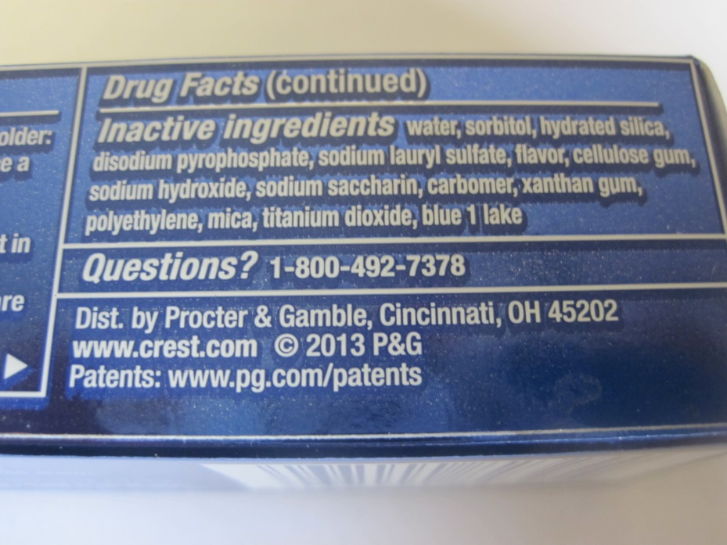
CREST 3D WHITE TOOTHPASTE PACKAGE

- JOIN THE CAMPAIGN TO PRESSURE COSMETIC COMPANIES TO STOP USING MICROBEADS IN THEIR PRODUCTS
- Go to www.beatthemicrobead.org to download a FREE smartphone application that will allow you to scan a product to see if it contains microbeads.
NOTE: this app. was created in the Netherlands in 2012, and most of the products identified are only found in Europe (although the manufacturers may be the same, the brand name may be different). The international version was just released in 2014, so they need help building a worldwide database of products that contain microbeads. If you scan a product that is not on their list (and this will probably happen) the website asks you to upload an image of the item and its barcode, so it can be added for future users. Help the Plastic Soup Foundation put pressure on manufacturers to stop polluting the environment!
- TEST THE PRODUCTS THAT YOU HAVE DISCOVERED CONTAIN PLASTIC TO SEE IF YOU CAN FILTER OUT MICRO BEADS.
- Squeeze a small amount of the product onto a coffee filter.
- Observe your sample-can you see the microplastic beads?
- Place filter over a container to catch the water after it passes through.
- Slowly pour water over the sample. You may need to gently stir the product (i.e. toothpaste) to get the ingredients to separate.
- Keep adding water until sample has dissolved.
- Describe what is left in the filter.
- Can you count the number of beads in the filter?
- Observe the ‘filtered’ water in the container—can you see any microbeads?
- If you find microbeads in the ‘filtered’ water, pour it through a clean coffee filter.
- Observe the new sample—are there microbeads in the filter? In the water?

MICROBEADS QUESTIONS:
- WHAT IS THE SIGNIFICANCE OF FINDING MICROBEADS IN THE FILTERED SAMPLE? (Hint: A coffee filter has very fine mesh that the fluid passes through and traps the particles, i.e. coffee grounds or in this case, microbeads).

- WHAT TYPES OF FILTERS DO THEY USE AT WASTE WATER TREATMENT PLANTS?

- CAN THOSE SYSTEMS FILTER OUT MICROBEADS?

- WHERE WILL THE MICROBEADS END UP?

- LIST SOME NATURAL/BIO-DEGRADABLE INGREDIENTS THAT CAN BE USED INSTEAD OF MICROBEADS TO ‘SCRUB CLEAN’ SKIN, TEETH OR SINKS.

- NAME THREE PRODUCTS THAT YOUR CLUB FOUND THAT ARE MICROBEAD-FREE AND OK TO USE.

- NAME THREE PRODUCTS THAT YOUR CLUB FOUND AND UPLOADED DETAILS TO THE BEAT THE MICROBEAD APP.

POLLUTION QUIZ

WHAT IS THE PLASTIC SOUP?
WHAT IS A GYRE?
WHAT IS A NURDLE?
WHAT IS ANOTHER NAME FOR THE PACIFIC GYRE?
WHO IS CAPTAIN CHARLES MOORE?

