University of Rhode Island

COVID-19 Safety Training for Research Laboratories and Field Research

Background
COVID-19 (coronavirus disease 2019) is caused by a novel coronavirus named severe acute respiratory syndrome coronavirus 2 (SAR-CoV-2). To cause COVID-19, the coronavirus SARS-CoV-1 infects the cells of the upper and lower respiratory track. To spread from an infected person to another individual, coronaviruses, which are very small (i.e., approximately 0.1 microns (µm) in diameter which is 1000 times smaller than the diameter of a human hair), are released in respiratory fluid. When an infected individuals cough, sneeze, or simply breath, virus is released in respiratory droplets that can range in size from less than 1 µm to greater than 100 µm. The larger droplets quickly fall to contaminate objects and surfaces. Smaller droplets can remain airborne for long periods of time and potentially infect other individuals that breath in these virus-laden droplets.

Layered Strategies
To minimize the risk of infection, a layered approach involving multiple strategies is necessary. The approaches below are required for those involved in research at the University of Rhode Island (URI).
 | Health Screening  Evaluate your symptoms daily. Do not report to work if you exhibit any COVID symptom. | Why? A self-assessment of symptoms is a good reminder to report changes to their health or their exposure risk.  Reminders:  - For symptoms see: CDC Symptoms of Coronavirus  - Adhere to URI requirements for symptom reporting. Requirements are likely to change.  - Report situations where a member of your household has tested positive.  - Visitors with unknown infection status should not be allowed in the laboratory
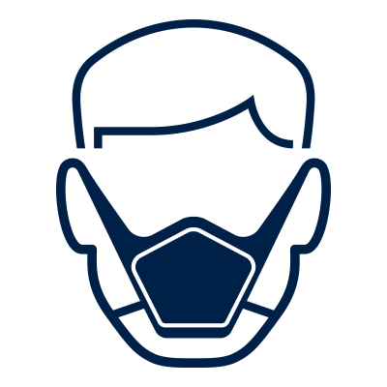 | Masks  Face Coverings are mandatory in all URI buildings | Why? Studies have indicated that individuals can be infectious even when not exhibiting symptoms.  Reminders:  - Free face coverings are available from URI. Contact URI EHS for more information
 | Physical Distancing  Remain at least fix feet apart, including in laboratories and field operations | Why? Transmission has been shown to occur through sustained close contact. URI has established minimum density targets of 113 square feet per person in order to reduce the likelihood of prolonged contact.  Reminders:  - Place tape on floors to mark six feet of separation on lab benches. Remember, 6 feet is not a magic number, further spacing is even better.  - Stagger work schedules (e.g., work alternate days, one group starts earlier, one group starts later) to reduce the number of staff/students in the lab at any one time  - Consider starting with core, minimum staffing and scale up at a later date.  - Conduct group meets via WebEx
 | Hygiene and Cleaning  Wash hands and disinfect surfaces frequently | Why? Touching one’s face with hands that have become contaminated is a common route of transmission of many infectious diseases.  Reminders:  - Disinfect laboratory space (e.g., high touch surfaces, bench tops) at least daily.  - Facilities staff will disinfect building common areas and high touched surfaces frequently.
 | Safety Culture & Communication  Remind everyone of the importance to follow the precautions. | Why? Sharing of timely, accurate, and pertinent information will be essential to engaging the URI community in measures to prevent the spread of COVID-19 within our campus community.  Reminders:  - Encourage open discussions on how to minimize infection risk in your area
 | Evaluate the Science  As the science evolves, we will evaluate and adjust accordingly | Why? The science is evolving on how to best prevent COVID-19. URI’s recommendations are guided by the best understanding of the current science. With that in mind, recommendations and requirements may change.

